The Law Society of Scotland Education Foundation
2022 Bursary Award Applications

The support offered will be a bursary each year of the LLB degree and the postgraduate Diploma (the awards may vary but could be around £2,500 per year, totalling up to £12,500 by completion of the qualifications). Just as important will be the opportunity to be supported by a mentor working in the legal profession throughout university. As well as the bursary, this is a career development programme and all successful applicants are expected to participate in a programme of events throughout the year. Further details can be found in our Terms and Conditions (see page 13).
To be eligible to apply you must answer yes to the following:
- You have an offer to study law (known as the LLB in) at one of the ten universities accredited by the Law Society of Scotland starting in 2022;
- Your circumstances mean you would be unable to attend university due to your financial situation;
- You are currently studying at school or college, or have left school or college within the last two years (but not currently attending university
When deciding who should receive a grant, the Trustees will have regard to applicants with particular financial hardship.
Please note, we can only support a limited number of students per year. Please read the terms and conditions on page 13 to ensure you are eligible to apply.
This form is for individuals wishing to apply for a bursary. On receipt of your application, we will contact your school/ college to request a report and reference.
Please complete every section of the form fully.
Applications should be made by 5pm on Friday 10 June 2022 to Milly Berndes-Cade by email (EmiliaBerndes-Cade@lawscot.org.uk).

If you have any issues completing an online application, please call 0131 476 8128 and we will assist you.

1. PERSONAL DETAILS

Home address should be the address that will be used for correspondence regarding your application.

Title (Mr/Mrs/Miss/Ms etc): | First Name:
Surname: | Home telephone number:
Address: | Mobile telephone number:
 | Email Address*:
Postcode: | Date of Birth
 | ___/____/_________
*We will mainly correspond with you via email so please ensure the address you have given us is accurate and you check your emails regularly.

2. EDUCATION

2.1 Please give details below of all secondary schools/colleges attended (most recent first).

School/ College | Address | Type (i.e. state/ independent) | Date started | Date left

2.2 School/ College referee
Please provide details of the appropriate person at your school/ college who will be able to provide a reference and complete a report in support of your application. Please advise this individual that we will be in touch with them directly to request that this be completed.
Name of referee
Position
School/ college
Phone
Email

3. ACADEMIC RESULTS

3.1 Starting with the most recent, please list relevant qualifications. Please also mark, where applicable, the grade awarded for any qualification. Please include any National 5 results as well as Highers.

If you are awaiting results please also complete section 3.2.
Subject | Level (e.g. Higher) | Result | Date Awarded

3.2 Predicted qualifications
If applicable, please ask your school/college to provide a reference for any result that you are predicted to get in your courses.
Subject | Level (e.g. Higher) | Predicted result | Date it will be awarded

3.3 Other qualifications
Please enter details of any further qualifications that you consider important for us to take into account as part of your application.
Additional qualifications | Level | Result | Date awarded

3. 4.
4. WORK EXPERIENCE

Starting with your most recent role, please list any work experience.
Position held | Place of work | Date started-date left | Paid/unpaid

4. DETAILS OF UNIVERSITY COURSE
Please list your chosen universities/ course starting with your first choice
University applied to | Course name | State of offer Conditional / Unconditional | Have you formally accepted this offer Yes/No? | Course start date | Is the course full/part time? | Will you be living at home or away?

Do you have a reserve choice of university if your first choice is conditional?

If your first or only choice is conditional, please state the conditions.

5. ADDITIONAL INFORMATION

Please answer yes/no to the questions below and provide further information where appropriate.
Do you intend to complete a four year honours degree?

Did you come to this country as a refugee or asylum seeker?

Will you receive a bursary from the Student Awards Agency for Scotland? Please specify the type and amount applied for, e.g. Young Students’ Bursary (£2,000), Care Experienced Students’ Bursary (£8,100)

Are you applying for a loan from the Student Awards Agency for Scotland, and if so, how much?

Are you applying or planning to apply for any other scholarships or bursaries? If so, please specify the details including the amount applied for. (Please note this will not necessarily preclude you from receiving a bursary from the Lawscot Foundation).

Are you in receipt of any other scholarships or bursaries? If so, please specify the details including the amount. (Please note this will not necessarily preclude you from receiving a bursary from the Lawscot Foundation).

Are you currently involved in a University Widening Participation Programme? If so, which? E.g. Top Up, Aspire North, Lift-Off, LEAPS, Focus West, Pathways to the Profession, etc

How many people are in your household? Please provide details
Do you have any dependents / caring responsibilities? Please detail

6. ABOUT YOU

6.1 In order than we know more about you, and your reasons for wishing to study law, please copy and paste your UCAS personal statement into the space below (continue overleaf).

Paste here

6.2 The Lawscot Foundation has been established by the Law Society of Scotland. The Society’s values are Respect, Openness, Progress, Integrity and Inclusion. Taking responsibility for your actions, being helpful and behaving with impartiality, respect and fairness are examples of behaviours expected from law students and future solicitors. Please provide examples of occasions where you have shown such behaviours (aligning with our values). Please also provide details of a referee who can support your answer.
You may refer to examples from school, university, work experience, voluntary, community or leisure pursuits (500 words max)
Please type your response here

6.3 The Lawscot Foundation programme contains three main elements: bursary, mentoring and career development opportunities.
Please detail what you believe you would gain from being part of the Lawscot Foundation programme.
Please type your response here (300 words max)

6.4 Financial support is an important part of this programme. Please outline how your financial situation impacts you and explain how this additional support would help you and what it would be used towards.
Please type your response here (max 300 words)

6.5 Please detail your career aspirations (100 words max).
This is for information only and will not form part of the selection process.

7. HOW DID YOU FIND OUT ABOUT THE LAWSCOT FOUNDATION?

Please let us know how you found out about the Lawscot Foundation by ticking the appropriate box.
☐ School | ☐ University (admissions team)
☐ Lawscot Foundation website | ☐ Friends / family
☐ Social media | ☐ Law Society of Scotland website
☐ Pathways to the Profession | ☐ REACH
☐ LEAPS | ☐ Lift Off
☐ Aspire North | ☐ Aim for Uni
☐ Who Cares? Scotland | ☐ Other (please specify below)

Other continued:__________________________________
8. TERMS AND CONDITIONS

The terms and conditions of the Lawscot Foundation programme are outlined here. Please read these carefully before submitting your application.
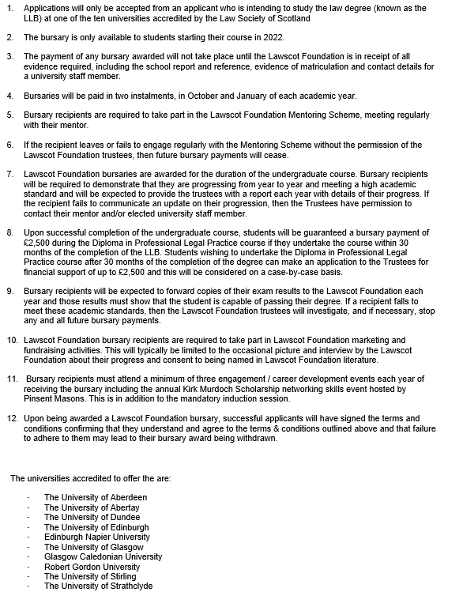

☐ I confirm that I have read and agree to the terms and conditions.

9. CRIMINAL OFFENCES

Have you ever been convicted of a criminal offence? (subject to The Rehabilitation of Offenders Act 1974 (Exclusions and Exceptions) (Scotland) Order 2003)
Yes No

If your answer to the above was YES please give details (offence, judgement, date). This is for our information and may not harm your application depending on the offence.

10. DECLARATION

I consent to the Law Society of Scotland using my personal information for the purpose of assessing my application in accordance with the Lawscot Foundation and understand that I can withdraw my consent at any time.
Yes ☐
I confirm that all the information in this application is accurate and I consent to the Foundation verifying information with my school/ college and the university as required
Yes ☐
I confirm that if I am successful with my application, I will attend the mandatory mentoring training day (date and time TBC)
Yes ☐

GDPR, Data Protection Act 2018. For information about how we use your personal data see our privacy policy at www.lawscot.org.uk
Before you submit the application have you:
- Completed all sections fully?
- Informed your school/ college referee that they should expect an email from the Lawscot Foundation requesting that they complete an online report and reference in support of your application?

Signature: Click here to enter text. Date: Click here to enter a date.

Please check you have completed every part of the form before submitting it.

Part B – Equal Opportunities Monitoring

The data collected in Part B will not be available to those involved in the short-listing or interview process. Such information will be held on an individual database in accordance with the Society’s Data Protection Policy. The database will only be accessible to those staff working on equality projects.
1. Ethnicity Please put an ‘X’ in the box you feel best describes your ethnic origins:
White
Scottish
Other British
Irish
Any other White background - please tell us about this
Mixed
Mixed - please tell us about this
Asian, Asian Scottish, or Asian British
Indian
Pakistani
Bangladeshi
Chinese
Other Asian background - please tell us about this

Black, Black Scottish, or other Black British
African
Caribbean
Other Black background - please tell us about this

Other ethnic background
Other ethnic background - please tell us about this

I would prefer not to answer this question…
I would prefer not to answer this question

2. Sex Please put an ‘X’ in the appropriate box:
Male
Female
I identify myself as something different – please tell us about it

3. Would you consider yourself to be transgender? Please put an ‘X’ in the appropriate box:
The term transgender refers to someone who considers that they do not identify strictly to one gender or the other. The term ‘transgender’ includes a number of sub-categories, which, among others, include transsexual, cross-dresser, transvestite, consciously androgynous people and the term gender dysphoria is often used to explain these tendencies.
Yes
No
I would prefer not to answer this question

4. Sexual Orientation Please put an ‘X’ in the appropriate box:
Heterosexual
Gay Man
Lesbian
Bisexual Man
Bisexual Woman
Other - please tell us about this
I would prefer not to answer this question

6. Religion/Faith/Belief Please put an ‘X’ in the appropriate box which best describes your religion, religious denomination, or body, if any, you below to:
None
Church of Scotland
Roman Catholic
Other Christian
Muslim
Jewish
Hindu
Buddhist
Sikh
Other - please tell us about this
I would prefer not to answer this question

7 Disability Do you consider yourself to have a disability?
Yes
No
I would prefer not to answer this question

