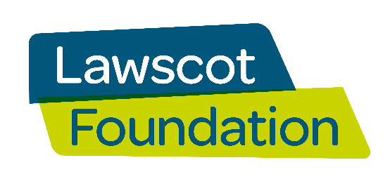
SCIO Scottish Charity no: SC046547
Lawscot Foundation Fundraising Committee Application form
Remit of the fundraising committee:
- Develop a fundraising strategy and oversee its implementation via an action plan.
- Take responsibility for coordinating a series of fundraising events and campaigns (events, raffles, sponsored walk, etc).
- Research and apply for suitable grants and trusts to support the fundraising aims, with support from LSS staff.
Name: ___________________________________________________________
Email:___________________________________________________________
Please submit your completed application form to darrenkerr@lawscot.org.uk
Please select the role you wish to apply for
Fundraiser / event planner – attending meetings regularly and taking responsibility for planning and delivering fundraising events /campaigns - either working individually or occasionally within a small group.
Bid researcher / writer – attending meetings regularly and taking responsibility for researching and assisting with applying for suitable grants and trusts to support the fundraising aims (with support from Law Society staff).

Skills and Experience
Please provide information detailing your skills and experience which are relevant to the role you are applying for:

Please provide a personal statement explaining the reasons for your application.

