The Law Society of Scotland Education Foundation
2024 Bursary Award Applications
This application has three sections which individuals wishing to apply to the Lawscot Foundation should complete:
- The application form
- Providing a referee
- Getting to know you and your interest in law
Please ensure you complete every section fully before submitting your application.
This is a career development programme with three key components: a bursary, mentoring and events to help develop the skills you might need to be a great solicitor. The bursary will be awarded each year of the LLB degree and the postgraduate Diploma in two instalments, normally in October and January. It could be around £2,750 per year, totalling up to £13,750 by completion of the qualifications. Just as important will be the opportunity to be supported by a mentor working in the legal profession throughout university. Successful applicants are expected to participate in skills events throughout the career development programme. Successful applicants are also expected to attend a mandatory induction session on Wednesday 4th September from 9:30-13:00. Please endeavour to keep this free. Further details can be found in our Terms and Conditions (see page 15).
To be eligible to apply you must answer yes to all of the following:
- You have an offer to study law (known as the LLB) at one of the ten universities accredited by the Law Society of Scotland starting in 2024;
- Without financial support you would struggle to access and participate in higher education (university);
- You are currently studying at school or college, or have left school or college within the last two years (but not currently attending university)
When deciding who should receive a grant, the Trustees will have regard to applicants with financial hardship.
Please note, we can only support a limited number of students per year so not all applicants will be successful. However, there will be additional spaces on the mentoring and career development programme reserved for students who are selected by the trustees. Please read the terms and conditions on page 15 to ensure you are eligible to apply.
On receipt of your application, we will contact your referee to request a report and reference.
Please complete every section of the form fully.
Applications should be made by 5pm on Friday 21 June 2024 by email to
LawscotFoundation@lawscot.org.uk
If you have any issues completing an online application, please call 0131 476 8128 and we will assist you.
1. PERSONAL DETAILS

Home address should be the address that will be used for correspondence regarding your application.

First Name: | Surname:
Mobile telephone number: | Home telephone number:
Address: | Email Address*:
Postcode: | Date of Birth
 | ___/____/_________
*We will mainly correspond with you via email so please ensure the address you have given us is accurate and you check your emails regularly.

2. EDUCATION

2.1 Please give details below of all secondary schools/colleges attended (most recent first).

School/ College | Address | Type (i.e. state/ independent) | Date started | Date left

2.2 School/ College referee
Please provide details of the appropriate person at your school/ college who will be able to provide a reference and complete a report to enhance your application. If applicable, please ask this referee to provide support for any result that you are predicted to achieve. These predicted qualifications should be entered by you in section 3.2. Please advise this individual that we will be in touch with them directly to request that this be completed.
Name of referee
Position
School/ college
Phone
Email

3. ACADEMIC RESULTS

3.1 Starting with the most recent, please list your qualifications. Please also mark, where applicable, the grade awarded for any qualification. Please include any National 5 results as well as Highers/ Advanced Highers.

If you are awaiting results, please also complete section 3.2.
Subject | Level (e.g. Higher) | Result | Date Awarded

3.2 Predicted qualifications
If applicable, please ask your school/college referee to provide a reference for any result that you are predicted to get in your courses.
Subject | Level (e.g. Higher) | Predicted result | Date it will be awarded

3.3 Other qualifications
Please enter details of any further qualifications that you consider important for us to take into account as part of your application.
Additional qualifications | Level | Result | Date awarded

3. 4.
4. WORK EXPERIENCE AND EMPLOYMENT HISTORY

Starting with your most recent role, please list any work experience and employment history
Position held | Place of work | Date started-date left | Paid/unpaid

5. DETAILS OF UNIVERSITY COURSE
Please list the universities you have applied to starting with your first choice
University applied to | Course name | Type of offer Conditional / Unconditional | Have you formally accepted this offer Yes/No? | Course start date | Is the course full/part time? | Will you be living at home or away?

Do you have a reserve choice of university if your first choice is conditional?

If your first or only choice is conditional, please state the conditions.

6. ADDITIONAL INFORMATION

Please answer yes/no to the questions below and provide further information where appropriate.
Do you intend to complete a four-year honours degree?

Did you come to this country as a refugee?

Did you come to this country as an asylum seeker?

Will you receive a bursary from the Student Awards Agency for Scotland? Please specify the type and amount applied for, e.g. Young Students’ Bursary (£2,000), Care Experienced Students’ Bursary (£9,000)

Are you applying for a loan from the Student Awards Agency for Scotland, and if so, how much?

Are you applying or planning to apply for any other scholarships or bursaries? If so, please specify the details including the amount applied for. (Please note this will not necessarily preclude you from receiving a bursary from the Lawscot Foundation).

Are you in receipt of any other scholarships or bursaries? If so, please specify the details including the amount. (Please note this will not necessarily preclude you from receiving a bursary from the Lawscot Foundation).

Are you currently involved in a University Widening Participation Programme? If so, which? E.g. Top Up, Aspire North, Lift-Off, LEAPS, Focus West, Reach Programme, etc
How many people are in your household? Please provide details
Do you have any dependents / unpaid caring responsibilities? Please detail
Are you estranged from your family? I.e., Living without support or contact from your family?

7. ABOUT YOU

7.1 In order than we know more about you, and your reasons for wishing to study law, please copy and paste your UCAS personal statement into the space below (continue overleaf).

Paste here

7.2 The Lawscot Foundation has been established by the Law Society of Scotland. The Society’s values are Respect, Openness, Progress, Integrity and Inclusion. Taking responsibility for your actions, being helpful and behaving with impartiality, respect and fairness are examples of behaviours expected from law students and future solicitors. Please provide examples of occasions where you have shown such behaviours (aligning with our values).
You may refer to examples from school, college, work experience, voluntary, community or leisure pursuits (500 words max)
Please type your response here

7.3 The Lawscot Foundation programme contains three main elements: the bursary, mentoring and events to help develop the skills you might need to be a great solicitor. Please detail what you believe you would gain from being part of the Lawscot Foundation programme. You can find out more about what it is like to be a Lawscot Foundation student on our website.
Please type your response here (300 words max)

7.4 Financial support is an important part of this programme. Please outline how your financial situation impacts you and explain how this additional support would help you and what it would be used towards.
Please type your response here (max 300 words)

7.5 Please detail your career aspirations (100 words max).
This information helps us match you to your mentor if you are a successful applicant. It will not form part of the selection process.

8. HOW DID YOU FIND OUT ABOUT THE LAWSCOT FOUNDATION?
Please let us know how you found out about the Lawscot Foundation by ticking the appropriate box.
☐ School | ☐ University (admissions team)
☐ Lawscot Foundation website | ☐ Friends / family
☐ Social media | ☐ Law Society of Scotland website
☐ REACH | ☐ LEAPS
☐ Lift Off | ☐ Aspire North
☐ Aim for Uni | ☐ Who Cares? Scotland
☐ Other(please specify below)

Other continued:__________________________________
9. TERMS AND CONDITIONS
The terms and conditions of the Lawscot Foundation programme are outlined here. Please read these carefully before submitting your application.
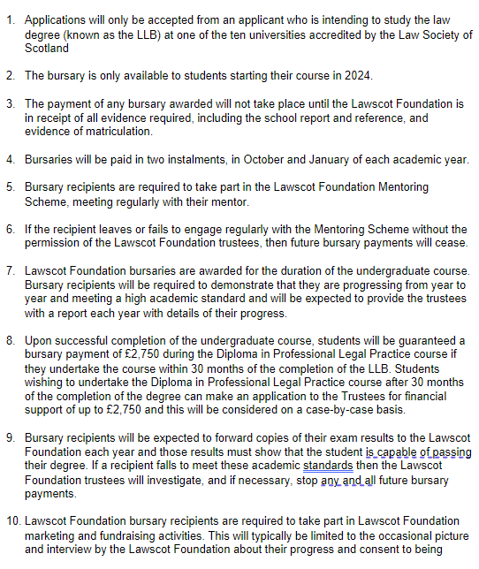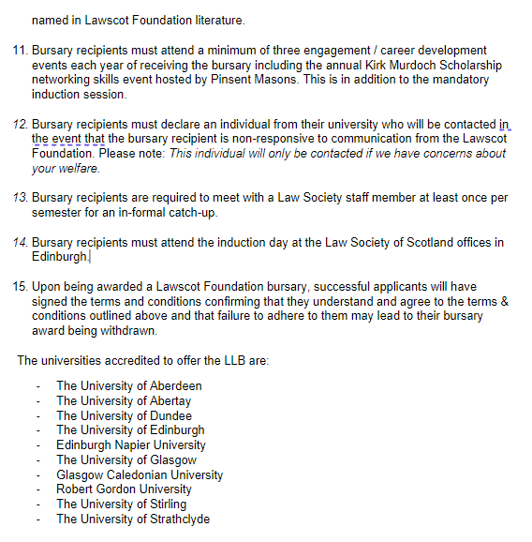

☐ I confirm that I have read and agree to the terms and conditions.

10. CRIMINAL OFFENCES

Have you ever been convicted of a criminal offence? (subject to The Rehabilitation of Offenders Act 1974 (Exclusions and Exceptions) (Scotland) Order 2003)
Yes No

If your answer to the above was YES please give details (offence, judgement, date). This is for our information and may not harm your application depending on the offence.

11. DECLARATION

I consent to the Law Society of Scotland using my personal information for the purpose of assessing my application in accordance with the Lawscot Foundation and understand that I can withdraw my consent at any time
Yes ☐
I confirm that all the information in this application is accurate and I consent to the Foundation verifying information with my school/ college and the university as required
Yes ☐
I confirm that if I am successful with my application, I will attend the mandatory mentoring training day Wednesday 4th September from 9:30am-13:00.
Yes ☐

GDPR, Data Protection Act 2018. For information about how we use your personal data see our privacy policy at www.lawscot.org.uk
Before you submit the application have you:
- Completed all sections fully?
- Informed your school/ college referee that they should expect an email from the Lawscot Foundation requesting that they complete an online report and reference in support of your application?

Signature: Click here to enter text. Date: Click here to enter a date.

Please check you have completed every part of the form before submitting it.

Part B – Equal Opportunities Monitoring

The data collected in Part B will not be available to those involved in the short-listing or interview process. Such information will be held on an individual database in accordance with the Society’s Data Protection Policy. The database will only be accessible to those staff working on equality projects.
Submission of the data in Part B is voluntary and will not affect your application in any way.
GDPR, Data Protection Act 2018. For information about how we use your personal data see our privacy policy at www.lawscot.org.uk

1. Ethnicity Please put an ‘X’ in the box you feel best describes your ethnic origins:
White
Scottish
Other British
Irish
Any other White background - please tell us about this ð
Mixed
Mixed - please tell us about this ð
Asian, Asian Scottish, or Asian British
Indian
Pakistani
Bangladeshi
Chinese
Other Asian background - please tell us about this ð

Black, Black Scottish, or other Black British
African
Caribbean
Other Black background - please tell us about this ð

Other ethnic background
Other ethnic background - please tell us about this ð

I would prefer not to answer this question…
I would prefer not to answer this question

2. Sex Please put an ‘X’ in the appropriate box:
Male
Female
I’d prefer to self-identify – please tell us about it ð

3. Would you consider yourself to be transgender? Please put an ‘X’ in the appropriate box:
According to the Scottish Trans Alliance, transgender/trans person are equivalent inclusive umbrella terms for anyone whose gender identity does not fully correspond with the sex they were assigned at birth. This includes, but is not limited to, trans men, trans women and non-binary people.
Yes
No
I would prefer not to answer this question

4. Sexual Orientation Please put an ‘X’ in the appropriate box:
Heterosexual
Gay Man
Lesbian
Bisexual Man
Bisexual Woman
None of the above - please tell us about this ð
I would prefer not to answer this question

6. Religion/Faith/Belief Please put an ‘X’ in the appropriate box which best describes your religion, religious denomination, or body, if any, you below to:
None
Church of Scotland
Roman Catholic
Other Christian
Muslim
Jewish
Hindu
Buddhist
Sikh
None of the above - please tell us about this ð
I would prefer not to answer this question

7 Disability Do you consider yourself to have a disability?
Yes
No
I would prefer not to answer this question

